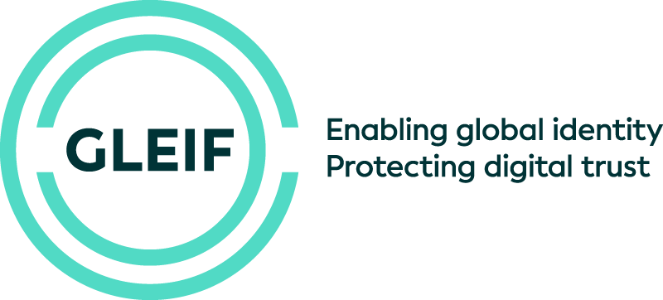

Contact Details
Appendix 12

GLEIF
Revision Version 1.7
2024-06-26
Contact Details of the Parties
to be completed by GLEIF and the LOU at time of signature of the MA, and
to be kept accurate and up-to-date throughout the Accreditation and the duration of the MA by exchanging files or by updating the details in GLEIF’s Communications Portal

GLEIF | LOU
Basic contact details
Legal domicile:
Global Legal Entity Foundation (GLEIF)
St. Alban-Vorstadt 12
CH-4052 Basel (Switzerland)
Commerce-Register ID: CHE-200.595.965
Frankfurt Office:
Bleichstrasse 59
DE-60313 Frankfurt/Main (Germany)
Phone (Switchboard):
Basel: +41 61 5087045
Frankfurt: +49 69 9074999-0
General E-Mail Address:
info@gleif.org
Authorized Signatory / Signatories
Alexandre Kech
CEO (joint signature at two)
Mail: Alexandre.Kech@gleif.org
Phone (direct line): +49 69 9074999-11
Sven Schumacher
General Counsel (joint signature of two)
Mail: sven.schumacher@gleif.org
Mobile: +49 151 1710509

LOU Relationship Manager | LOU Relationship Manager
To be assigned upon successful Accreditation
Responsible for Accreditation and Validation
Antonia Christoforidi
Head of Accreditation & Public Affairs
Mail: antonia.christoforidi@gleif.org
Phone (direct line): +49 69 9074999-64
Responsible for Service Management
Anja Lechner
Head of Service Management
Mail: anja.lechner@gleif.org
Phone (direct line): +49 69 9074999-25
Responsible for Data Quality Management
Zornitsa Manolova
Head of Data Quality Management
Mail: zornitsa.manolova@gleif.org
Phone: (direct line) +49 69 9074999-52
SLA Escalation Level Responsibilities
Level One: LOU Relationship Manager
Level Two: Head of Service Management
Level Three: CEO | Level Three: CEO

